Student name: Yuan Tang / Ruchen Ding /Luisa Patricia Cristovao Mota

Student ID: 041128267 / 040812415/041101258

**USAGE INSTRUCTIONS**

User could open the Access application to add, delete, or modify record on views movies, customers and rentals, and the update history will be restored.

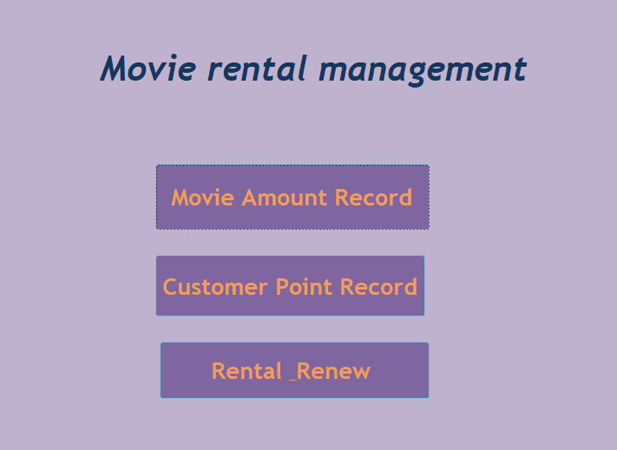

When open the **view_movies** form, by using the buttons, user could add a new movie, delete the specific movie, or change the existed record. Then the customer’s operation will be updated on the **movie_amount** table, which is the history of changes on ***inventoryAmount***.

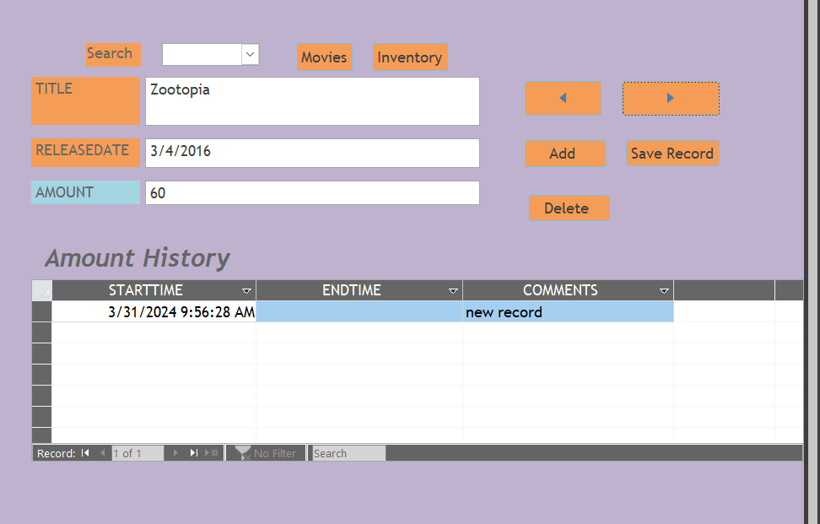

When open the **view_customers** form, by clicking the buttons, user could add new customer information, delete one record, or make changes to the existing data. Then the customer’s operation will be updated on the **customer_point** table, which is the history of changes on ***points***.

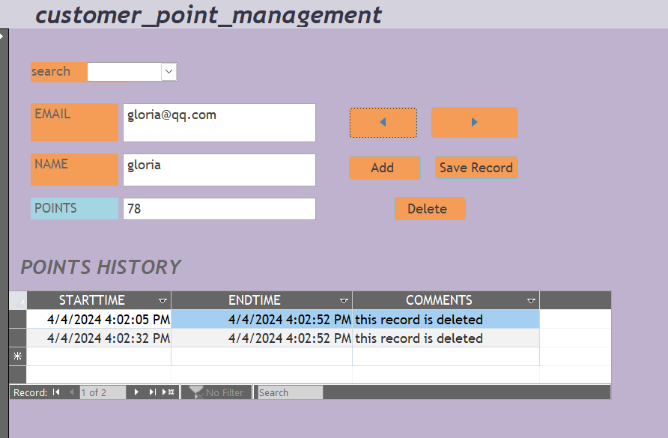

When open the **view_rentals** form, with the help of the buttons, user could create new rental record, delete some rental information, or modify the specific rental record. Then the customer’s operation will be updated on the **rental_record** table, which is the history of changes on ***rentalDate***.

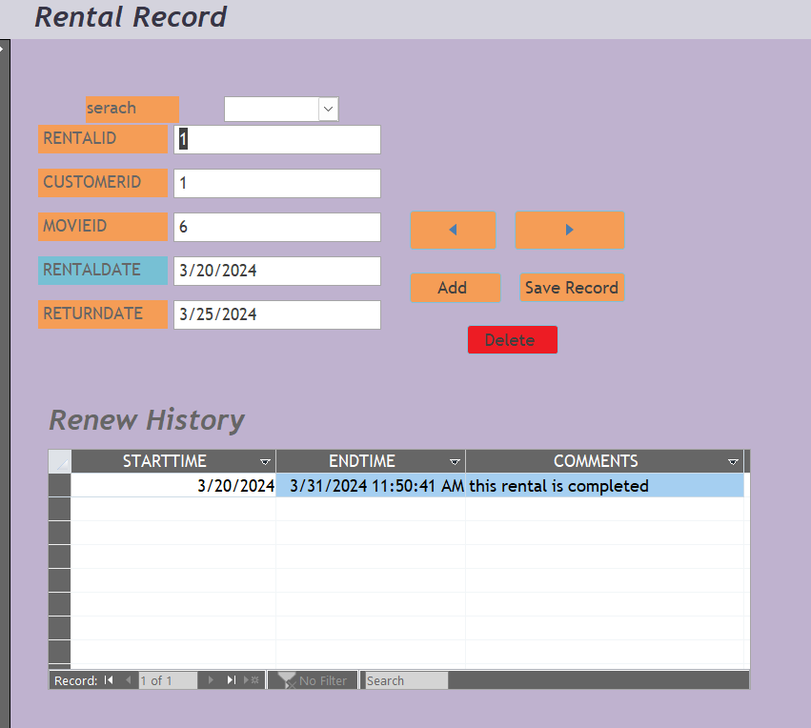

Also, customers could open report rpt_movies to see the full list of movies.

